**Sexual dimorphic blue bands are intra-sexual aposematic signal in the pond male damselfly**

Md Kawsar Khan1*, Marie E. Herberstein1

1. Department of Biological Science, Macquarie University, NSW-2109, Australia

**Author of correspondence:**

Md Kawsar Khan

Department of Biological Science

Macquarie University, Sydney

NSW-2109, Australia

Email: [Kawsar.khan@mq.edu.au](mailto:Kawsar.khan@mq.edu.au)

Phone: +612-9850-6279

Key words: aposematism, sexual conflict, sexual dimorphism, visual modelling, damselfly

Abstract

Introduction:

According to sexual selection theory, conspicuous male coloration in animals can evolve if they improve attractiveness to female or increase success in male-male competition or both (Darwin 1871). One striking example of conspicuous male coloration is sexual dimorphic coloration also known as ornamental coloration because of its limited application in sexual attraction only. In such cases, males exhibit their ornamental coloration during courtship display and females prefer mating with more conspicuous male that is often associated with male qualities such as better physiological conditions (body mass, body size, immunity, and better nutritional condition), larger territory and higher social status (ref). On the other hand, in many species where males do not exhibit courtship display, male-limited dimorphic coloration can still evolve as an intra-sexual signal irrespective of female preferences. Conspicuous dimorphic male coloration can display male fitness to avoid the cost of unnecessary fight (ref) or unprofitability as a mate-partner to avoid unwanted mating encounter from other male (ref).

Sexual dimorphic blue bands are commonly found in many damselflies of Coenagrionidae family. In these damselflies, males neither maintain territories, nor do they perform courtship displays. The mate searching males hover around the breeding ponds looking for a mating partner which resembles a ‘scramble’ competition among males. After encountering a female, the male approach from above and grasp the female to engage into mating. Because of that, females cannot see the color of an approaching males. Moreover, the males can coarse a female to engage into mating even when it is unwilling to mate. As a consequences of that, the females do not seem to have a choice over whether or not they mate or with whom, making inter-sexual selection an unlikely mechanism to drive male-limited color dimorphism. Sherratt and Forbes (2001) proposed that conspicuous male coloration in these damselflies is not a signal to females rather it is a warning signal to other males to avoid costly mating harassment. In a ‘scramble’ mating competition erroneous male-male mating occurrence is not uncommon (). In this circumstances, male-limited conspicuous coloration can evolve to display their unprofitability as a mate to conspecific males.

However, Finke (1997) argued that, females can show mating unwillingness and avoid tandem formation by hiding themselves, by flying away, by death feigning, by abdomen curling and by wing raise signal. Moreover, even after a tandem formation male needs female’s cooperation for bending her abdomen to from wheel to receive sperm. Female can show resistance in this stage and can delayed wheel formation and even dissociate from the wheel. In the presence of such strong female choice, female would be able to reject unwanted males. In this circumstances, sexual dimorphic ornamental coloration can evolve from preferences. Although intriguing female preferences for male coloration is yet to be tested in damselfly.

In *Xanthagrion erythroneurum*, adult males have two blue bands on the dorsum of abdominal segments 8 and 9 (S8 and S9) where the female does not have this bands (Figure 1a, 1b). We aim to determine the function of this male-limited blue bands in this damselfly. We aim to experimentally test both sexual selection hypothesis and antiharassment aposematic hypothesis. If this male specific blue bands evolve through female preferences, we predicted mating success of a male with blue bands will be higher than the success of a male without them. On the other hand, if blue bands function as an antiharassment signal, the presence of the blue bands will antagonize the mating desire of a male. The best way to experimentally validate the hypothesis will be painting the blue bands in female’s abdomen and observe their mating decision of males. We predict that the presence of the blue bands will repel males and thus females bearing blue bands will be avoided, even though males are able to recognize females based on other female cues.

Methods and Materials

Study species

The Red and blue damselfly, *X. erythoneurum*,is a medium size damselfly (19-21 mm) of Coenagrionidae family (Zygoptera: Odonata). This species is widely distributed across all Australian states and commonly found in ponds, marshes and dams (Theischinger and Hawking). The adult male can be easily distinguished from the other Coenagrionidae species by the red face, red thorax, first two and half red abdominal segments, and by the blue bands in abdominal segments eight and nine. In the Sydney region, the species can be seen in flight from September to March and their reproductive season lasts throughout the whole period (ref).

We collected adult male and female X. erythroneurum damselflies using an insect sweeping net from the lake situated in the North Ryde campus of Macquarie University, NSW, Australia. No permission were required to collect the damselflies because this species is not protected in Australia and studies were not conducted inside any national park or protected area.

Reflectance spectra

We measured the reflectance spectra of the abdominal blue bands of the males from the segments S8 and S9 and the black coloration of the female in the same segments with a Jazz Ocean optics spectrophotometer (Ocean optics, USA). We set the spectrophotometer at an integration time of 20 milliseconds with an average of five successive scans. We used a PX-2 pulse xenon light source and took the measurements relative to a white standard WS-1. We placed the specimens perpendicular to the light source and took spectra from a uniform distance. We took spectra of the plant leaves from the pond site where the damselflies usually perch to quantify the background spectrum. We averaged three measurements for each damselfly and background plant leaf.

Discriminability

We used a discriminability index (D) to estimate the chromatic discriminability (Ds) of damselfly abdominal colouration (blue in male and black in female) against the natural background based on the index proposed by Hastad et al. [11]:

$Ds=$ $\frac{\overline{{ΔS}_{D}}- \overline{{ΔS}_{B}}}{\sqrt{{ΔS}_{D}}}$

Where $\overline{{ΔS}_{D}}$ is the average of the chromatic distance of each damselfly spectrum to the measured background spectra and $\overline{{ΔS}_{B}}$ is the average chromatic distance between each background leaf sample. We used a similar rationale for calculating achromatic discriminability (DL) based on the quantum catches of the green photoreceptor since bees and other insects use this photoreceptor to detect achromatic contrast [12]. The discriminability values (chromatic and achromatic) indicate whether the blue bands of males or black abdomens of females are detectable against the natural background ─ a value above zero indicates the signal is visible. Because it is unclear if this species has a tri- or a tetrachromatic visual system, we calculated the discriminability for both and applied unpaired t-tests to compare the chromatic and achromatic discriminability between the sexes.

Female preferance experiments

We manipulated the color of the damselflies using non-toxic colour paint (Tim and Tess poster paint). We used black color to hide the blue bands of the male abdomen. For the control males we applied the black color in the dorsum of abdominal segments S7. We kept one manipulated and one control male with two females in an insect mating cage (58cm × 32cm × 34cm). We placed the cage close a natural lake, in the natural sunlight and observed their sexual interaction from a distance of approximate one meter. We calculated the number of tandem and wheel formation of control and manipulated males. In case tandem did not last until wheel, we calculated the duration of tandem before it dissociate. We also recorded the time taken to reach from tandem to wheel formation and the duration of wheel. A successful trial was counted when a male form a tandem with a female. If tandem did not occur within 30 minutes we record it as an unsuccessful trial. The experiment were continued until we reach sixty successful trial.

Male choice experiments

We manipulated female colour using non-toxic colour paint (Tim and Tess poster paint). We painted female with two blue bands matching the colour and brightness of the males (Figure 1a). In two separate experiments, we varied the position of the bands ─ in the first, the blue bands were applied in the same position as on the male (segments S8 and S9) but in the second experiment we painted the blue bands on segment S4. To control for the paint, we applied black paint over the natural black patches on the control females.

We placed four damselflies (two males, one control female and one manipulated female) into an insect mating cage (58cm × 32cm × 34cm) at the edge of a pond and observed their behavioral interactions. We terminated a trial if a male successfully formed a tandem with the female or after 20 minutes if no tandem occurred. For each experiment, we performed 40 successful trials between 10 am to 4 pm (November 2016 to January 2017) when mating usually occurs in the field. We applied chi-square test to compare the frequency of tandem pairs in each experiment.

Results

Damselfly spectra

The reflectance spectra of the male blue abdominal bands peaked between 450 and 481 nm while the female abdominal segments did not show any peaks but a gradual increase with increasing wavelengths (Figure 1c). Like males, manipulated females bands also showed reflectance peaks in this region (471-472nm) (Figure 1c).

Discriminability

Both male abdominal blue bands and female abdominal colouration were chromatically and achromatically discriminable in the trichromatic damselfly visual system against the natural background (Figure 1d and Figure 1e). The chromatic discriminability of the male blue bands was significantly (p < 0.001) higher than female (Figure 1d). However, no significant discriminability was found between the sexes achromatically (figure 1e). In case of a tetrachromatic visual system, both sexes are discriminable against their background ─ males are chromatically more discriminable (p < 0.001) while achromatic contrasts are significantly higher in female (p < 0.001) (Supplementary figure 1 (a, b)).

Female preference

The natural and manipulated males do not differ significantly in terms of tandem and wheel formation. Similarly, there is no significant difference in tandem duration, the time required from tandem to wheel formation and wheel duration between control males and manipulated males.

Male choice assays

When females carried blue bands on abdominal segments S8 and S9 (similar to male colouration) males significantly (χ2 = 4.900, df= 1, p < 0.05) preferred control females over manipulated females (Figure 2a). However, when the females carried the blue bands on abdominal segment S4, the males formed tandems at the same rate with manipulated and control females (χ2 = 0.400, df= 1, p = 0.527) (Figure 2b). We did not observe any male-male tandem formation.

Discussion

We found that the damselfly visual system can discriminate sexual dimorphic male blue bands from female abdominal coloration. We manipulated the male blue bands and observe the female preference for mating partner between the altered and control males. If the make blue bands are sexually selected ornamental coloration then the male with the blue bands will have sexual success over males without blue bands. Our results, however, shows that there is no significant difference in the number of tandem between the control and manipulated males. As males approach above from the female during tandem formation, the females cannot immediately see male coloration and cannot reject an approaching male. One might argue in a cage experiment a female cannot fly away from an approaching male even if it wants to, and the outcome can be due to restrictive movement of the females. A female can still rejects a male and dissociate from the tandem, or can delay the wheel formation. We did not, however, find difference of tandem duration, number of wheel formation and the duration of wheel between the control and manipulated males. From our knowledge, our study provide first experimental evidence showing in damselflies the female does not have preference for dimorphic coloration in males. Even if a female wants to reject a male, it can’t because the males can still coarse a female to mate. As a consequence of that, male-limited dimorphic coloration is unlikely to evolve through female preferences.

We also found that when females carried blue abdominal bands in the same position as males, they were less attractive than control females or females that carried blue bands elsewhere on the abdomen. There are several possible interpretations for our observations: Males failed to recognize manipulated female as potential mates or the blue bands act as a warning signal to males. We argue for the latter interpretation as males had sufficient cues available to identify females. Odonates use tactile and visual cues for mate recognition [8]. The female black abdomen is the most important cue for mate recognition [13] however, males also use body size [14], abdomen shape [13, 15], flight pattern [15], female display [16, 17], thorax colouration and pattern [18, 19] and chemical cues [20] for mate recognition. Moreover, Gorb (1998) showed that males recognize females based on part of their whole image or by the presence of any female part (thorax, head) [13]. Hence, we argue that the males in our study can still identify the manipulated females as a conspecific female based on her overall phenotype. However, the presence of the blue bands on the female’s abdomen repelled males and may thus function as a warning signal, possibly indicating an unprofitable mating partner.

To define the conspicuous coloration that display unprofitability Pulton used the term ‘aposematism’. Later on, ‘aposematism’ was typically used in the context of predator-prey interaction where bright, vivid coloration of a prey signals their unpalatability to predators. However, aposematic signals are not restricted to interspecific communication, neither are the functions limited to predation avoidance. For example, in *Battus phileno* butterflies, the color pattern of the larva is an intraspecific aposematic signal to repel conspecific females from ovipositing on the same leaves, thereby reducing intraspecific competition. In damselflies Sherrat and Forbes applied the concept of aposematism in a sexual context and coined the term ‘antisexual aposematism’ to explain the function of conspicuous coloration to avoid unwanted sexual harassment. The hypothesis was later supported in *Nehalennia irene* damselfly, where abdominal blue colouration on males repelled conspecific males [10]. Our present finding further solidify this hypothesis by showing the males avoid mating with females when they bear the warning signal even know the females as potential mate based on other mate recognition cue.

Our results showed that the spatial location of the aposematic bands is crucial for their function. The bands were only effective on the terminal abdominal segment. This make sense considering the mating biology of damselflies where males approach females from behind to form a tandem [8]. Hence, an aposematic signal will function best if presented on the distal dorsal body side. Moreover, male damselflies often raise their tail in a threat display towards conspecific males [17]. Therefore, the aposematic signaling in male damselfly depends on spatial location and is only effective when presented at the tip of the abdomen.

*Xanthagrion erythroneurum* warning signal comprises two blue bands separated by black abdominal coluration. The blue and black adjacency presumably generates high internal contrast as well as high chromatic and achromatic contrast against a natural background [21]. Aposematic signals are most effective when they generate high internal contrast and against the background [22]. Moreover, high colour contrast signals enhance speed and stability of avoidance learning and reduce recognition errors [23].

Aposematism benefits both the signaler and the receiver. In *X. erythroneurum*, the warning signal helps males to avoid male-male tandem formation, which is costly in terms of time and energy for both males. Abdominal blue bands in males are commonly found in many damselfly species [Peer observation, see also 10, 13] and thus our findings raise a tantalizing question whether blue abdominal bands function as an aposematic signal across many odonatan taxa.

References:

Figure 1:

1. Photograph of a male and (b) a female X. erythroneurum (c) Aggregated reflectance spectra (mean ± SD) of the male (N= 20, red line), female (N = 14, green line), manipulated female (N= 8, blue line) and background plant leaves (N= 31, purple line) (d) Chromatic discriminability (Ds) and (e) Achromatic discriminability (DL) of male and female abdominal (S8-S9) colouration in trichromatic damselfly visual system.

Figure 2:

Figure 3:

(a) The number of control female and manipulated female (blue bands on segments S8 and S9) and (b) control female and manipulated female (blue bands on segment S4) recorded in mating pairs during the mate choice experiment (n = 40, * p<0.05).

Figure 1:

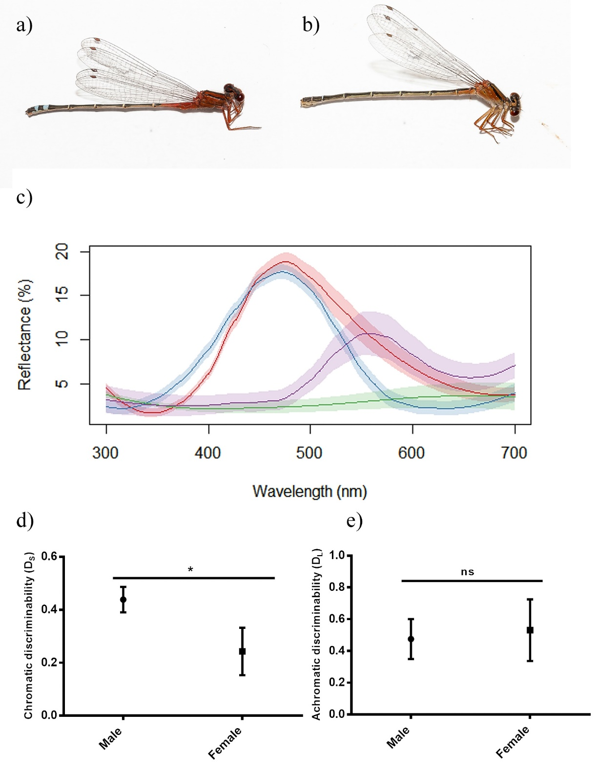

Figure 2:

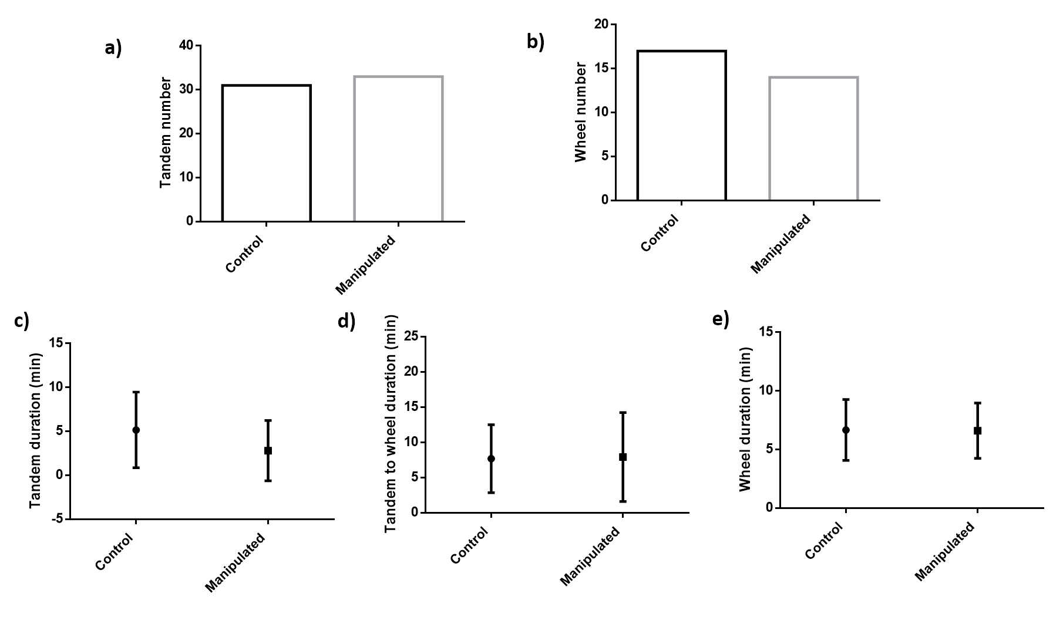

Figure 3:

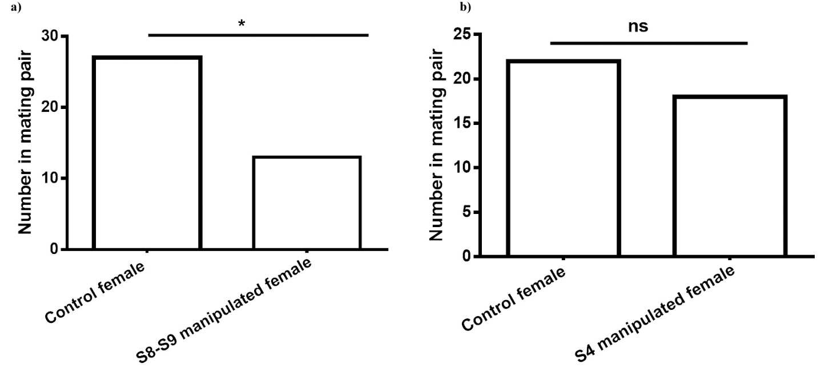

Further females can mate multiple times with different male and the last males usually remove the sperm of previous males. Hence even if a male coarsely mate with a female by re-mating another male afterward and selecting the wanted sperms the females can show a cryptic choice as well. In such circumstances, when female ultimately control the outcome of the mating the males should cooperate with females to minimize the cost of coercing in terms of time and energy.